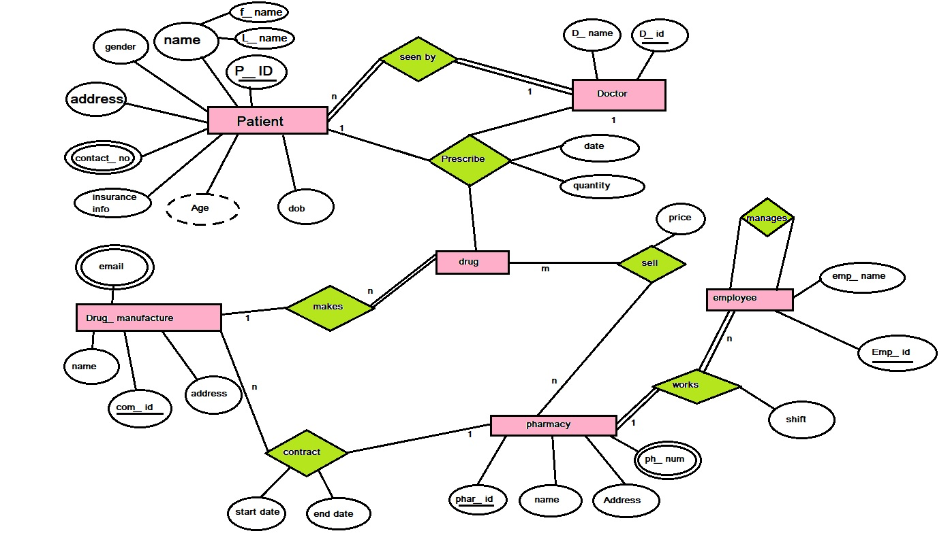

**Schema**

**Patient (Name, Gender, Address, Contact_no, Insurance_id, age, DOB, D_ID, Phar_id)**

Phar_id= pharmacy ID, D_ID=Doctor ID, Comp_ID= Company ID

**Drug_Manufacture (Name, Email, Comp_id, Address)**

**Doctor (D_name, D_id)**

**Employee (Emp_id, Emp_name, shift, Salary, PH_number)**

**Pharmacy (Phar_id, name, address, PH_number, Comp_id)**

**Patient**

|  |  |  |  |  |  |  |  |  |
| --- | --- | --- | --- | --- | --- | --- | --- | --- |
| **Name** | **Gender** | **Address** | **Contact no** | **Insurance Id** | **Age** | **DOB** | **D_ID** | **Pharma_id** |
| Mitul | M | Surat | 9898 | B125 | 21 | 21/10/2001 | D98967 | 62718 |
| Rittik | M | Himachal | 7489 | A213 | 22 | 30/11/2000 | D78921 | 68216 |
| Nikkhil | M | Up | 8787 | C4531 | 21 | 12/1/2001 | D16789 | 62718 |

**Drug_Manufacture**

|  |  |  |  |
| --- | --- | --- | --- |
| **Name** | **Email** | **Comp_id** | **Address** |
| Cadell Healthcare PVT | [Cadell@mail.com](mailto:Cadell@mail.com) | C9812 | USA |
| Cadex Laboratories | [Cadex@mail.com](mailto:Cadex@mail.com) | C1254 | INDIA |
| A.V.S Laboratories | [avs@mail.com](mailto:avs@mail.com) | C5683 | INDIA |

**Doctor**

|  |  |
| --- | --- |
| **D_Name** | **D_ID** |
| DR. Himanshu kumar | D16789 |
| DR. Neeraj Desai | D98967 |
| DR Rashmi Kayshap | D78921 |

**Employee**

|  |  |  |  |  |
| --- | --- | --- | --- | --- |
| **Emp_ID** | **Emp_Name** | **Shift** | **Salary** | **PH_number** |
| 456 | Rahul | Morning | 9000 | 8328 |
| 142 | Rohit | Afternoon | 8500 | 6754 |
| 875 | Harsh | Evening | 7000 | 9136 |

**Pharmacy**

|  |  |  |  |  |
| --- | --- | --- | --- | --- |
| **Phar_id** | **PName** | **PAddress** | **PH_number** | **Comp_id** |
| 67895 | MedPlus | Mumbai | 6754 | C5683 |
| 62718 | Apollo | Gujarat | 9136 | C9812 |
| 68216 | Medlife | Delhi | 8328 | C1254 |

Q. Include 10 logical queries with minimum 5 involving joins.

|  |  |  |
| --- | --- | --- |
| **1** | Find the name of patient who is from Himachal | |
|  | Select name from patient where address = ‘Himachal’ | πName(σAddress='Himachal'(Patient)) |
| **2** | Find name of Drug manufacture which is not in INDIA | |
|  | Select name from drug manufacture where address != ‘INDIA’ | πName(σAddress!='INDIA'(Drug_manufacture)) |
| **3** | Find the name of employee who’s salary is less then 8000. | |
|  | Select name from employee where salary<8000 | πEmp_Name(σSalary<8000(Employee)) |
| **4** | Find all information about Medlife | |
|  | Select * from pharmacy where name = medlife | πPhar_Id,PName,PAddress,PH_number,Comp_id(σPName='Medlife'(Pharmacy)) |
| **5** | Display all information of patient who’s insurance no = B125 | |
|  | Select * from patient where Insurance_id=B125 | πName,Gender,Address,Contact_no,Insurance_Id,Age,DOB,D_ID,Phar_Id(σInsurance_Id='B125'(Patient)) |
| **6** | Who is the doctor of mitul? | |
|  | Select D_name from Doctor natural join patient where name =’mitul’ | πD_Name(σName='Mitul'(Doctor⨝Patient)) |
| **7** | In which Pharmacy Rohit is working? | |
|  | Select name from employee natural join pharmacy where Emp_name =’Rohit’ | πName(σEmp_Name='Rohit'(Employee⨝Pharmacy)) |
| **8** | Who supplies Drugs to Apollo? | |
|  | select name from drug manufacture nature join pharmacy where name=’Apollo’ | π Name(σ PName ='Apollo'(Drug_manufacture⨝Pharmacy)) |
| **9** | Find the details of Employee who is working under pharma id 6754 | |
|  | Select * from Employee natural join pharmacy  Where PH_number=6754 | π Emp_ID,Emp_Name,Shift,Salary,PH_number(σ PH_number =6754 (Employee⨝Pharmacy)) |
| **10** | Find the name of patient who is purchasing drugs from Apollo. | |
|  | Select name from patient natural join pharmacy where name =’apollo’ | π Name(σ Name ='Apollo'(Patient⨝Pharmacy)) |

**RELAX RELATIONAL ALGEBRA**

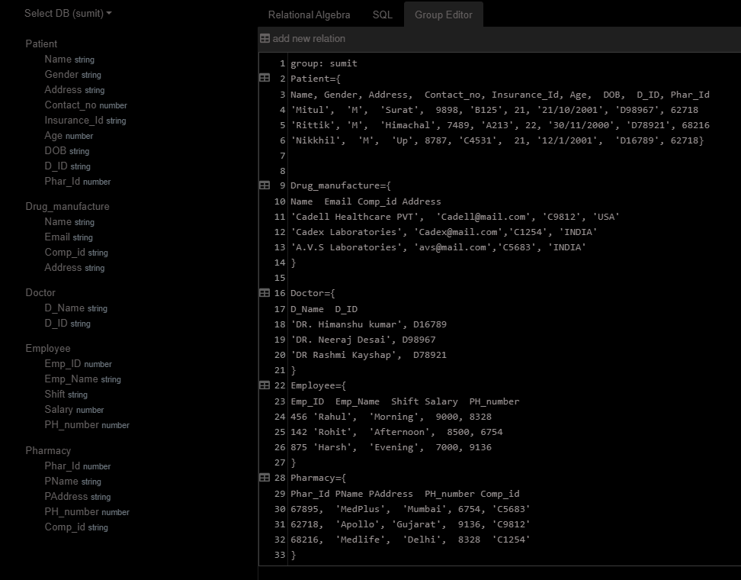

1

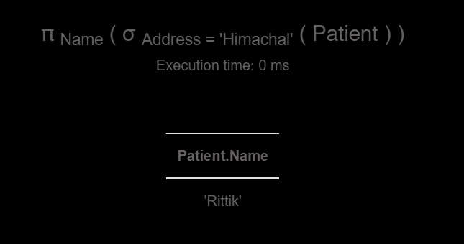

2

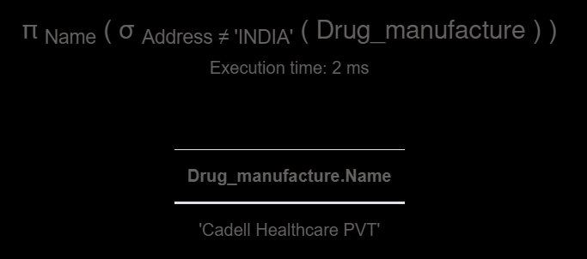

3

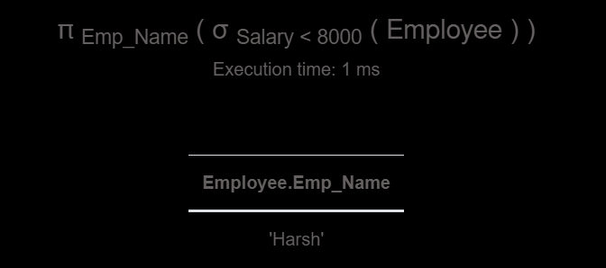

4

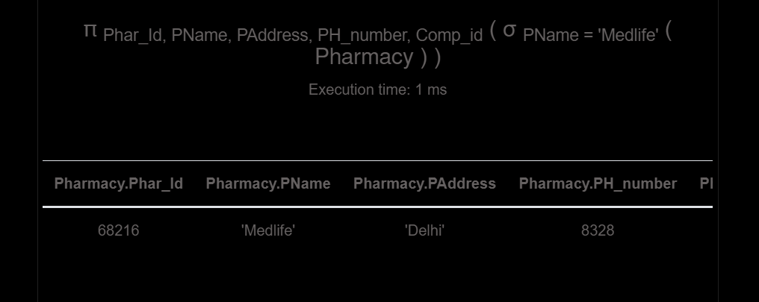

5

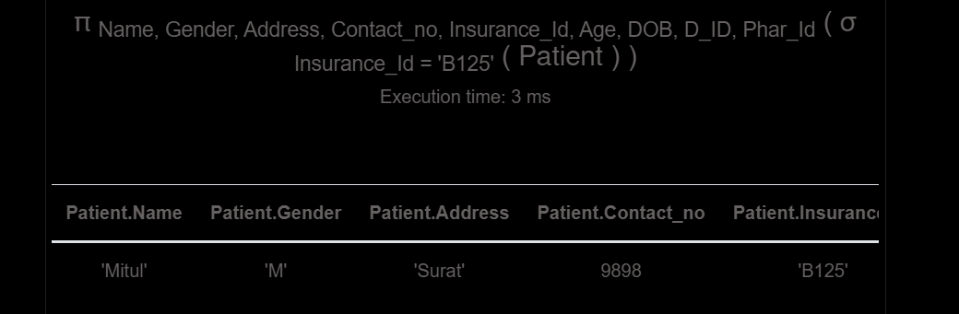

6

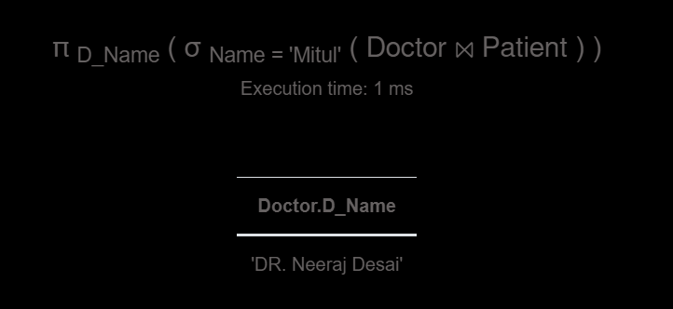

7

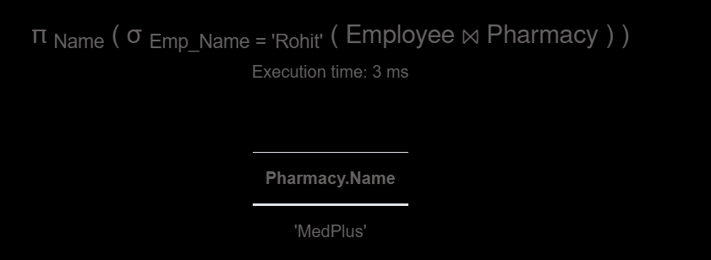

8

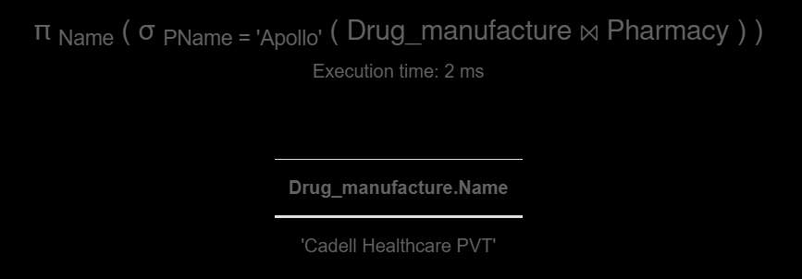

9

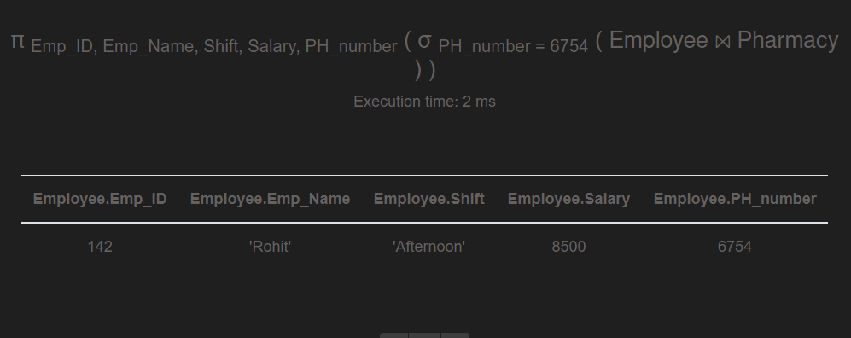

10

